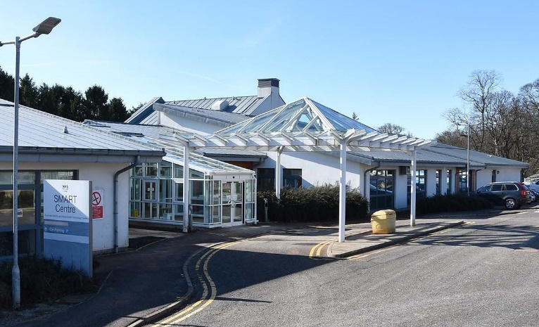SMART Centre Access Guide

The centre is located on South side of Astley Ainslie Hospital site in the Morningside area of Edinburgh. The postcode is EH9 2HL and the What3Words location is ‘vouch.blunt.occupy’ (<https://what3words.com/vouch.blunt.occupy>).

See site map overleaf.

# Getting Here by Public Transport

The nearest bus stops to the hospital site are:

* Blackford Pond stop on Cluny Gardens - Lothian Buses route 38
* Oswald Road stop on Charterhall Road - Lothian Buses route 38
* Grange Loan Gardens stop on Kilgraston Road - Lothian Buses route 9
* Grange Loan Gardens stop on Grange Loan - Lothian Buses route 9
* Springvalley Gardens stops on Morningside Road - Lothian Buses routes 5, 11, 15, 16, 23, 36 and Houstons Coaches 101, 101A, 102.

For further information checkout the websites for Lothian Buses ([www.lothianbuses.com](http://www.lothianbuses.com)) and Houston Coaches ([www.houstonscoaches.co.uk](http://www.houstonscoaches.co.uk)).

# Getting Here by Car

Access the site via the South Oswald Road, Canaan Lane or Grange Loan entrances and follow the signs pointing the way to the centre. Disabled parking is located to the front on the left side as you drive along towards the entrance that is in the centre of the building. There is also visitor parking just passed the entrance. It is possible to drop someone off directly at the door. Parking on site is free and there is also free on-road parking available on South Oswald Road. See site map overleaf.

# Reception & Toilets

There is level access into the reception and both sets of doors are fully automated (see photograph above). The reception desk is straight ahead and to the right. It is wheelchair accessible and staffed during opening hours. There is amble seating and space for wheelchairs. There is a vending machine for drinks and one for snacks. There is also a free drinking water fountain. There is a TV and digital information board. See photograph overleaf.

Within the reception there are two disabled toilets, one with baby changing facilities, and a Changing Places Toilet (<https://www.changing-places.org/find?toilet=1942>).

# Welcome Video

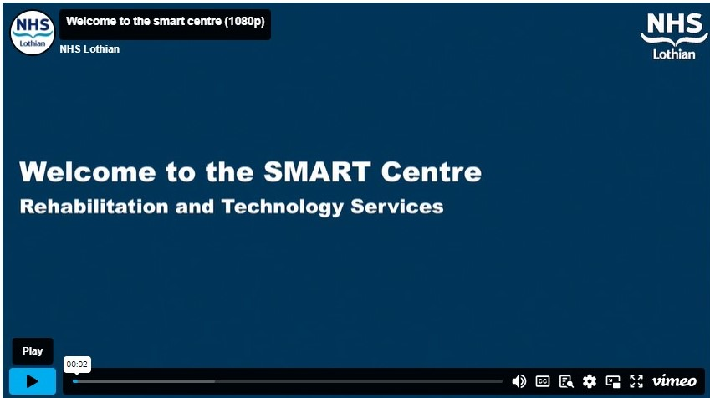

We have a video - check it out by clicking on the image to the right or this link: <https://player.vimeo.com/video/746866759>.

# Contact Us

Call 0131 537 9177 and choose the applicable option, or checkout our website at [www.smart.scot.nhs.uk](http://www.smart.scot.nhs.uk) for online ways to submit feedback and requests.

# Astley Ainslie Hospital Site Map

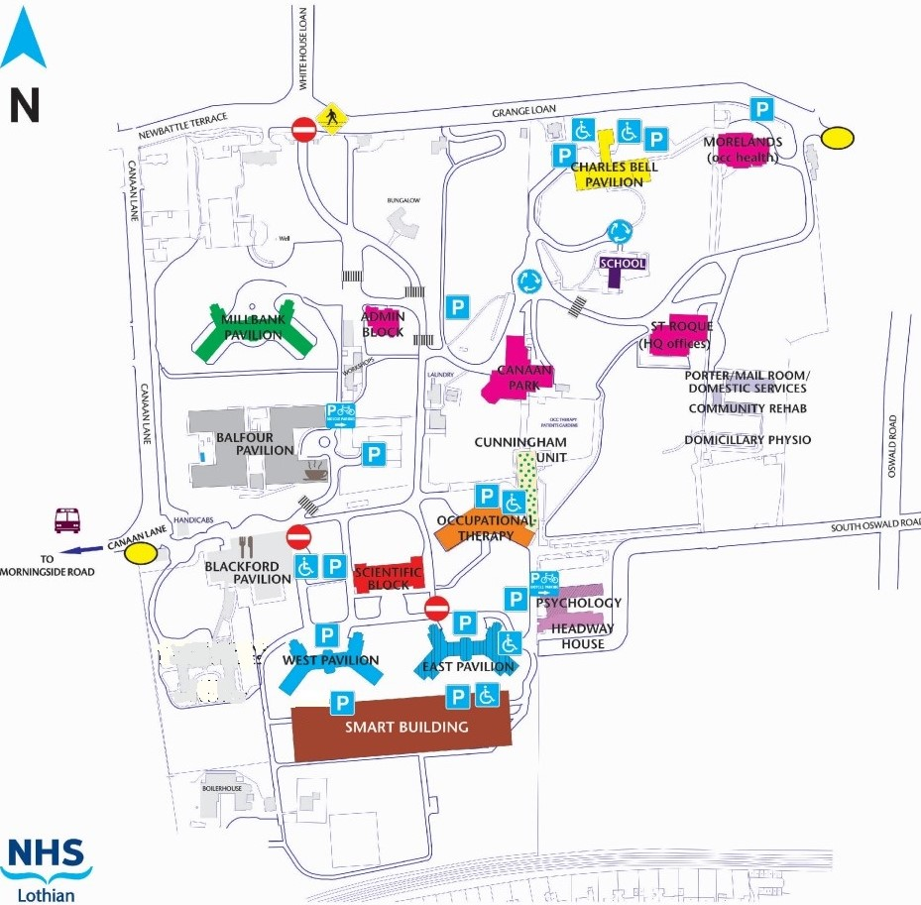

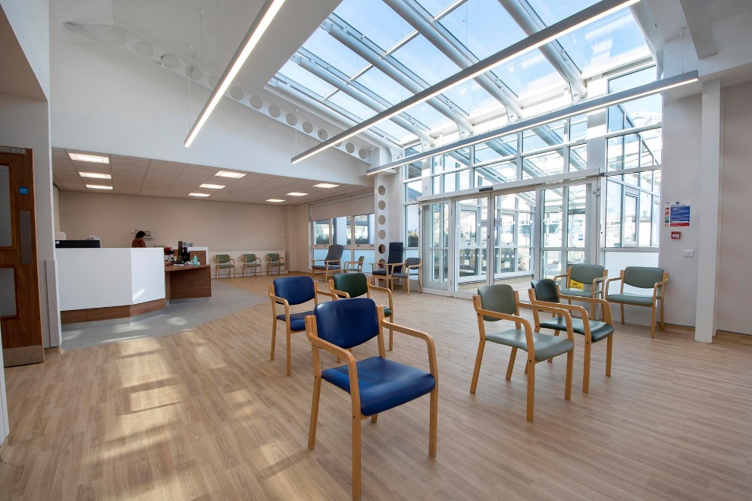

Vehicle and pedestrian entrance

SMART Centre Entrance

Photograph showing reception with entrance on right and desk on left.