**Anderson Gait Analysis Laboratory**

SMART Centre,

Astley Ainslie Hospital,

133 Grange Loan Edinburgh,

EH9 2HL

Information Sheet for Children

**What is Gait Analysis?**

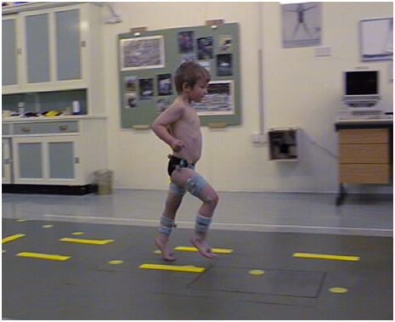

Figure 1 Walking in the gait lab

Gait analysis means looking at someone’s walking, to find out why they walk the way they do.

**Why do we do gait analysis?**

We might do gait analysis just to see how someone is walking, so that we can look again a bit later and see if it is any better. We might also do gait analysis if you are going to get some treatment to help your walking get better, then we will do the walking test before and after the treatment. If the doctor is planning to do some surgery on your legs, he asks us to do a gait analysis before the operation to help him decide exactly what to do. Then he will ask you to come back again after the operation to check that everything is OK. Sometimes we do gait analysis to look at how well someone’s splints are working, then we do the walking tests without any shoes on, and then wearing the splints and shoes, so we can see what difference they are making.

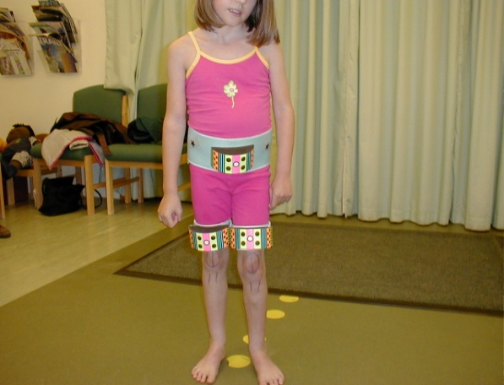**What happens when you go to the gait lab?**

We will show you all the cameras and equipment that we use to do the gait analysis. Then we will ask you to change into shorts or swim suit, so we can see your legs clearly to see how they move. Jan, who works in the gait lab, might draw pictures on your knees, so the camera can see them. Sometimes we also put coloured straps on your legs as well – you can see them in the picture to the right (figure 2).

Figure 2Coloured straps on legs

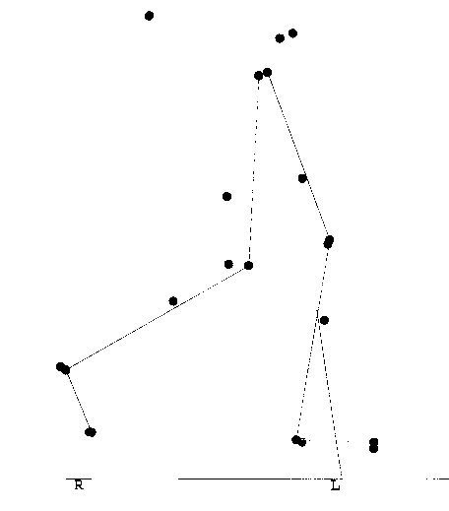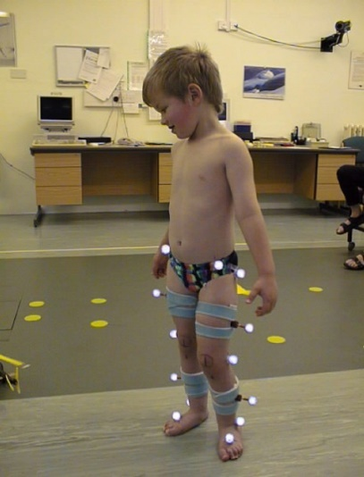After this, we will stick little balls called markers on your legs, you can see them in the picture to the left (figure 3). They look shiny because they are covered in reflective tape (like you sometimes have on trainers), so they are shining with the flash from the camera.

Figure 3 Markers on legs and hip

Then we will ask you to walk up and down, like the boy is doing in the picture on the front (figure 1).

Figure 4 Legs on the computer program

Some of the cameras that video you walking are special cameras linked to the computer that the Clinical Scientist will be working. We see your legs on the computer looking a bit like in the figure above right (figure 4)…

We will measure your legs, to see how far your hips, knees and ankles move, and see how strong you are. The girl below is having her legs measured (figure 5).

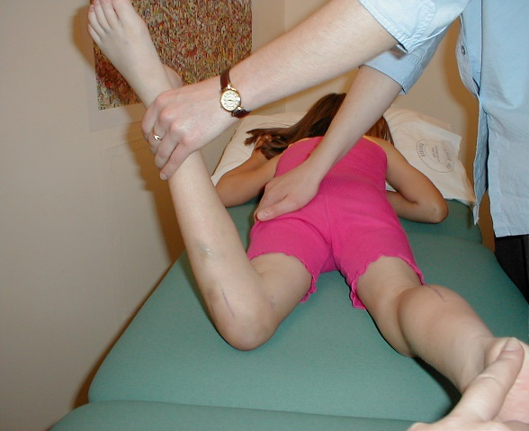

Figure 5 Girl's legs being measured