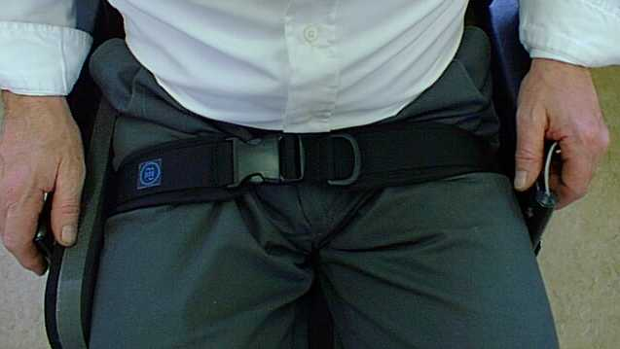Pelvic Harness

Your pelvic harness (also known as a hip belt) has been provided to help prevent you from slipping forwards in your seat. For it to work properly it should be positioned across the tops of your thighs so that it pulls downwards, rather than just backwards. It must be suitably tight enough so you cannot slide under it. This is very important.

# FASTENING THE BELT

1. Lengthen the belt before fastening it by slackening the straps attached to the loops (“D” rings) for tightening & loosening. Note that belts will have different attaching mechanisms, some with one tightening loop and some with two. Some of these designs are depicted in the photograph below.

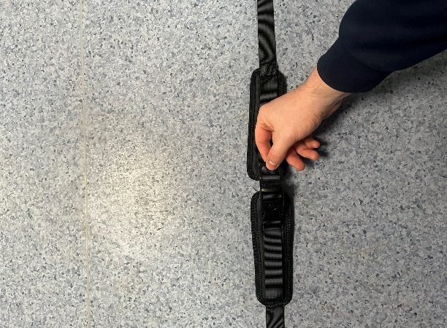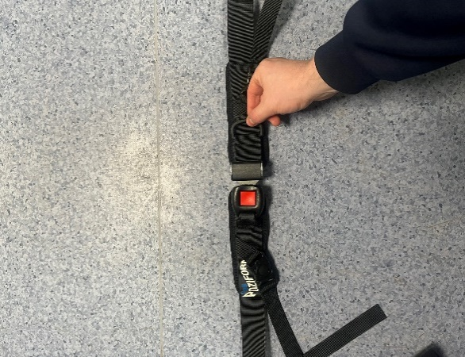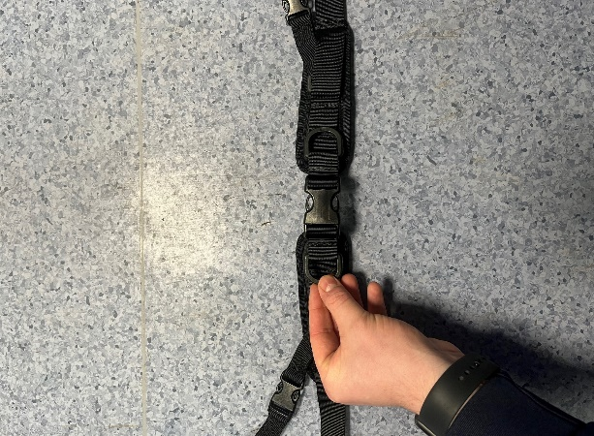

Loops for tightening & loosening belt

2. Make sure you are positioned properly in the seat with your lower back against the back support or back canvas.

3. Fasten the belt in the normal way.

4. Pull on the tightening/loosening loops until the belt is snug around your legs. It should be tight enough to prevent you from slipping forwards but still provide adequate comfort. As a rule, you should be able to slide two fingers between the harness and your thighs.

# TRANSPORT

If you use your wheelchair when travelling in a vehicle, please read the Wheelchair Seating Safety [WSS-INF-XX] sheet. For transportation, this harness should **not** be relied upon to provide effective restraint. Nevertheless, it is important that the harness be correctly fastened to help maintain your posture and position within your wheelchair during travel. It is still a requirement in law to wear the crash-tested lap and shoulder restraint fitted to the vehicle by your transport provider.