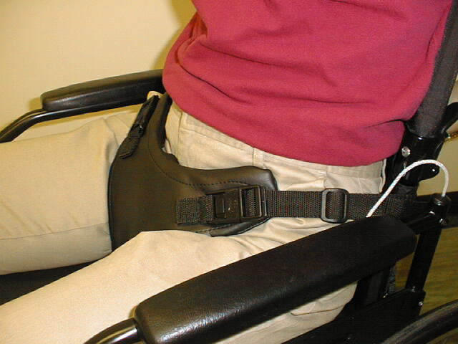Edinburgh (Groin) Harness

Your Edinburgh (Groin) Harness is intended to encourage a good sitting position and to prevent you from slipping down the seat. To work properly the straps need to be set at the correct length. The straps will be set at, or prior, to delivery of the harness, but should be checked periodically in case some adjustment is necessary.

The straps should be short enough to ensure that you are sitting with your lower back in contact with the lower part of your back support or wheelchair back canvas, but not so short that it is uncomfortable. Once the lengths of the straps are adjusted they should be secured using the ladders (see below) to ensure that the straps do not slip during use. Alternatively, camlocks (see below) might be located on the back support or near the rear of the seat that may allow easier adjustment of the strap length.

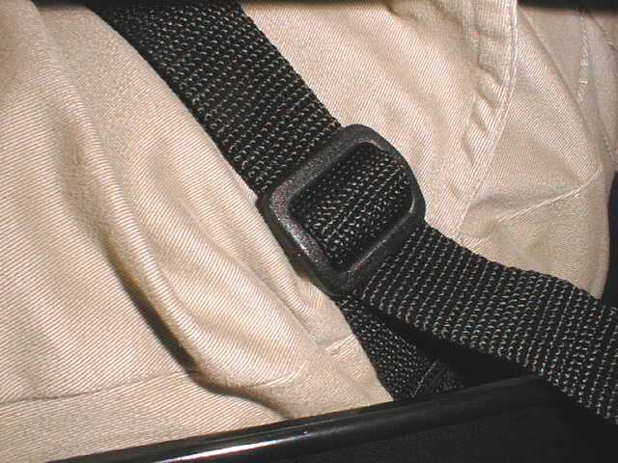 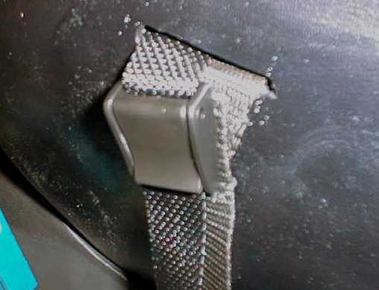

*Ladder Camlock*

# TRANSPORT

For transportation this harness should **not** be relied upon to provide effective restraint. You should, nevertheless, ensure that the harness is corrected fastened to help maintain your posture and position within your wheelchair. You will also need to use the crash-tested Wheelchair Tie-down and Occupant Restraint System (WTORS) lap and shoulder restraint fitted to the vehicle by your transport provider.