Four-Point Chest Harness

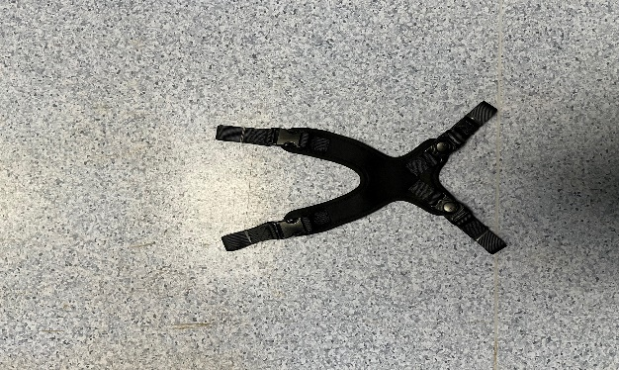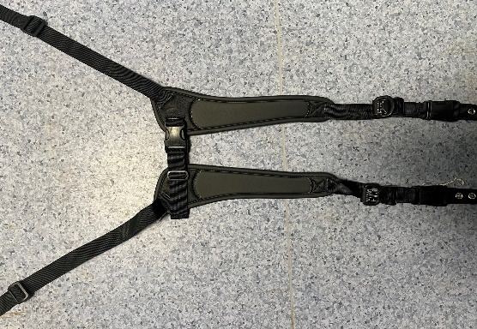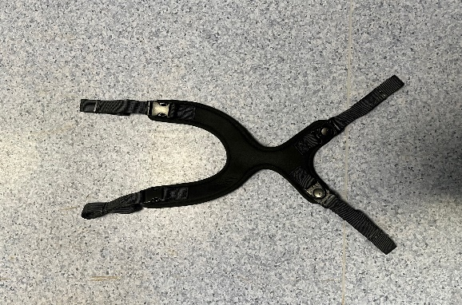

You have been supplied with a four-point chest harness to help prevent you from falling forward when you are sitting in your wheelchair. There are several different types, some of which are shown here. They are sometimes known as butterfly harnesses.

# FASTENING AND ADJUSTING

Most people will need someone else to help them to get the chest harness in position and adjust it correctly.

1. Before you get into your wheelchair, the harness straps should be unfastened or loosened and the harness itself should be out of the way.

2. When putting on the harness, bring around and/or over your head and fasten the release buckles onto the lower straps.

3. Adjust the top straps using the camlocks or pull D rings to get the harness in the best position. It should be sufficiently snug that you cannot come forward and lose contact with the back of your wheelchair. You should be able to slide two fingers between the harness and your body.

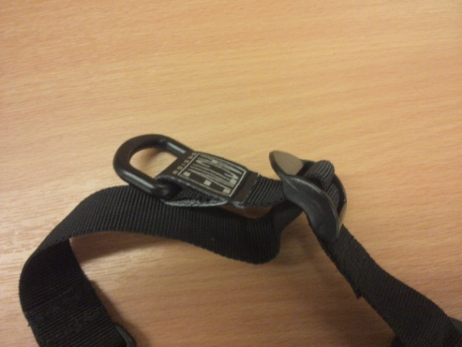

D-rings

**IMPORTANT**: Ensure that the front of harness is clear of your neck and that your lap belt (or pelvic harness) is fastened securely so that you do not slide forward in your seat.

# UNFASTENING THE HARNESS

1. Unfasten the top or lower buckles and lift the harness over your head or to the side of the wheelchair so that you are clear for transferring.

2. For some harnesses, the straps can be easily lengthened to assist with clearing the harness out of the way.

# TRANSPORT

If you use your wheelchair when travelling in a vehicle, please read the Wheelchair Seating Safety [WSS-INF-XX] sheet. For transportation, this harness should **not** be relied upon to provide effective restraint. Nevertheless, it is important that the harness be correctly fastened to help maintain your posture and position within your wheelchair during travel. It is still a requirement in law to wear the crash-tested lap and shoulder restraint fitted to the vehicle by your transport provider.