TREK 2 Pager Information Sheet

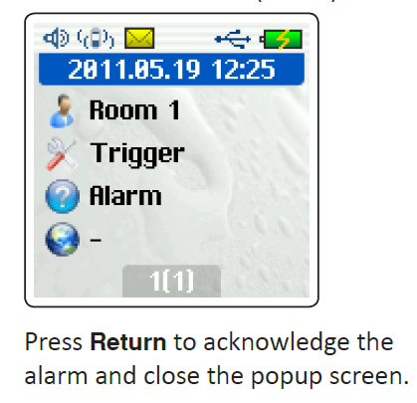

When the **pager** is triggered a popup screen similar to the one on right appears. An **envelope** in the top part of the screen is displayed.

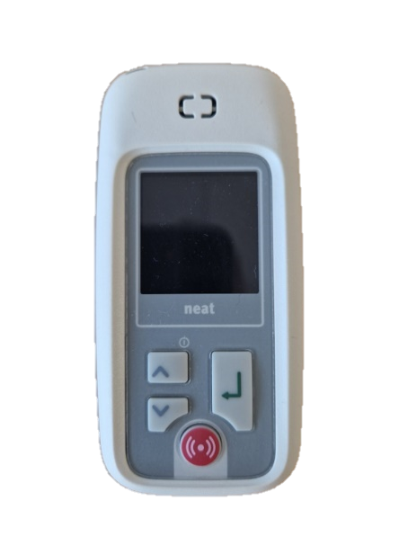Press the **return button** (you may have to press more than once) to remove the **envelope symbol** and the pager will stop sounding.

Return

**NB The return button is the only button that requires pressing. DO NOT USE OTHERS**

The pager should be charged regularly (once a day or every other day).

Any issues with the equipment please call 0131 537 9423 or 0131 537 9177 (option 6).

NB the first number does not require the use of a keypad during the call and so is recommended for anyone dialling from an environmental control system.