What happens after you have been to the gait lab?

Your doctor will look at your video and the measurements that we get from the computer.
Then the next time you go to see the doctor at the hospital, he will talk to you about your walking, and see if there is anything that needs to be done to make it any better.

If you are worried about coming to the gait lab, or if you are not sure about anything, you or your Mum or Dad can give Alison a call and she will explain everything to you. Alison is one of the physios who works in the gait lab.

Her telephone number is:
0131 537 9435

Look forward to seeing you!



For further information on the Anderson Gait Analysis Laboratory including its statement of purpose please refer to WWW.CMASUKI.ORG


SMART
Services

Y:\Q_Drive\QAGAIT\FORMS
GA3_ch V4
Author: AR
Review Date: 15/01/10

What is gait analysis?

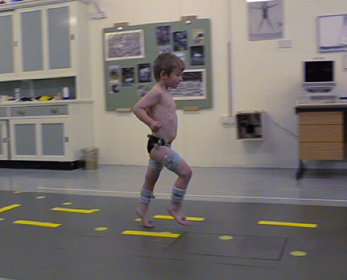

The Anderson Gait Analysis Laboratory
Edinburgh

Information sheet for children

What is gait analysis?

Gait analysis means looking at someone’s walking, to find out why they walk the way they do.

Why do we do gait analysis?

We might do gait analysis just to see how someone is walking, so that we can look again a bit later and see if it is any better. We might also do gait analysis if you are going to get some treatment to help your walking get better, then we will do the walking test before and after the treatment. If the doctor is planning to do some surgery on your legs, he asks us to do a gait analysis before the operation to help him decide exactly what to do. Then he will ask you to come back again after the operation to check that everything is OK. Sometimes we do gait analysis to look at how well someone’s splints are working, then we do the walking tests without any shoes on, and then wearing the splints and shoes, so we can see what difference they are making.

What happens when you go to the gait lab?

We will show you all the cameras and equipment that we use to do the gait analysis. Then we will ask you to change into shorts or swim suit, so we can see your legs clearly to see how they move. Alison, who works in the gait lab, might draw pictures on your knees, so the camera can see them. Sometimes we also put coloured straps on your legs as well – you can see them in the picture here.

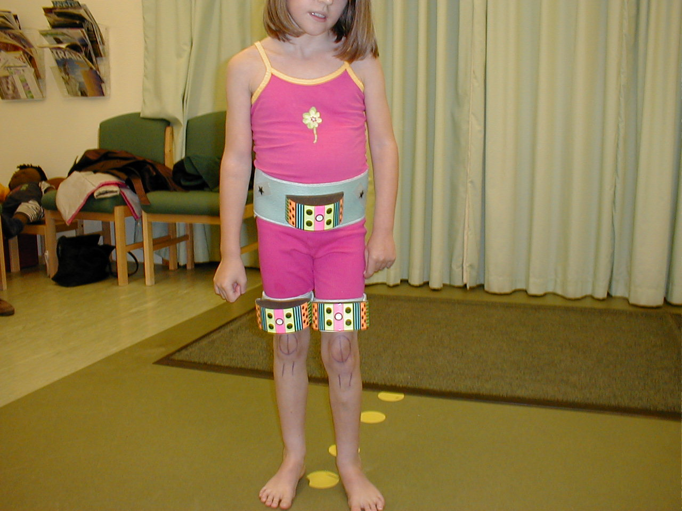

After this, we will stick little balls called markers on your legs. This is Ewan with his markers on. They look shiny because they are covered in reflective tape (like you sometimes have on trainers), so they are shining with the flash from the camera.

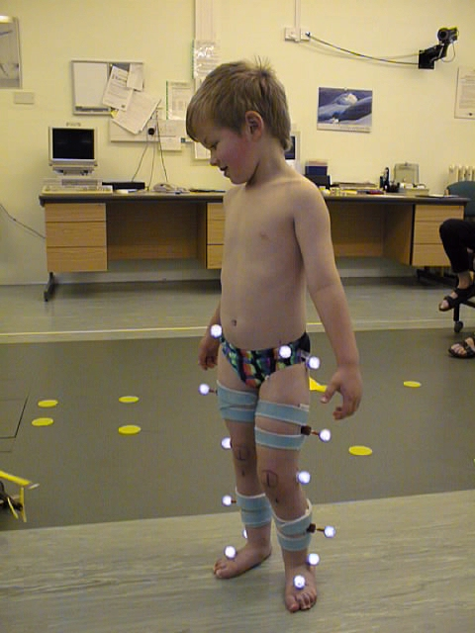
Then we will ask you to walk up and down, like Ewan is doing in the picture on the front.

Some of the cameras that video you walking are special cameras linked to the computer that Jan or Alison will be working. We see your legs on the computer looking a bit like this…

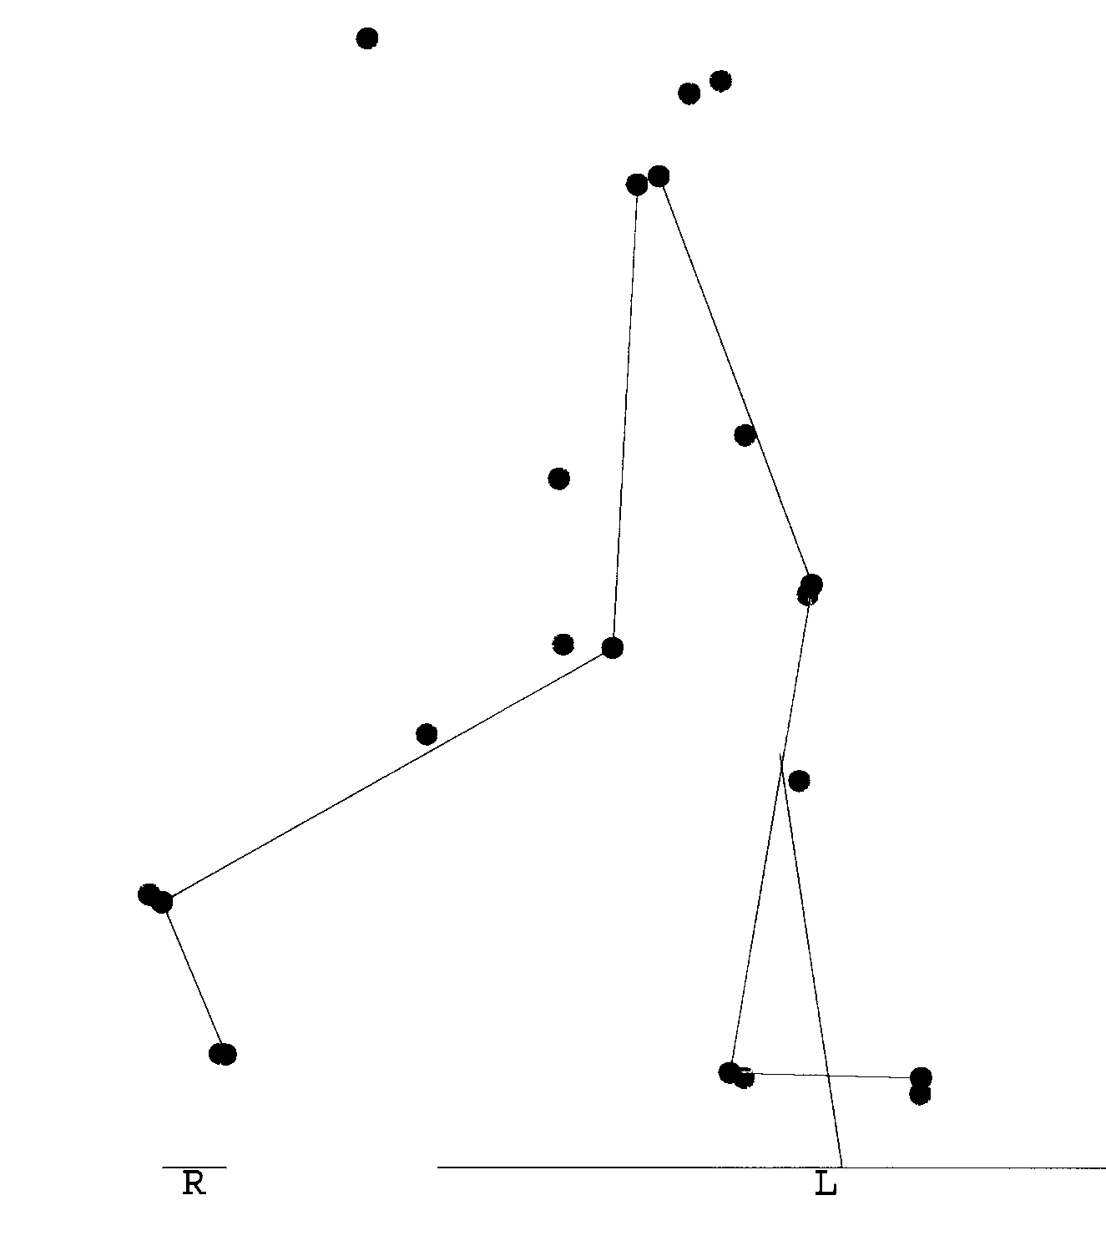

We will measure your legs, to see how far your hips, knees and ankles move, and see how strong you are. This girl is having her legs measured.



