Children and Young People Wheelchair and Seating Service Measurement Guide

Measurement instructions
Measurements can be taken in any unit (cm, mm, inches) but the same unit must be used throughout. Blocks or alternative flat objects e.g. folders or books, can be used or just use the palm of your hands as a guide. Measurements are best taken on a flat surface such as a block, plinth or hard chair with no armrests. A second person to assist may be useful but is not essential.

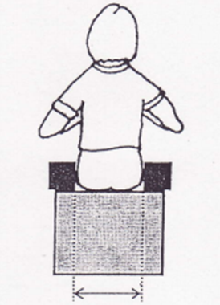 | 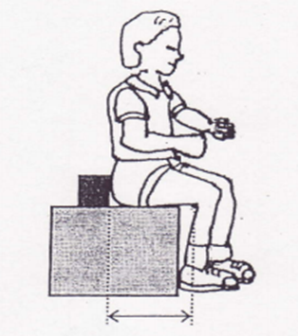
(HW) Hip Width – Measurement taken at widest point of hips from front or rear of child. Keep tape measure in straight line, not extended round thighs or stomach  HW = ____________ | (TL) Thigh Length – Place block behind bottom extending beyond width of hips and measure to back of knee  TL= ____________

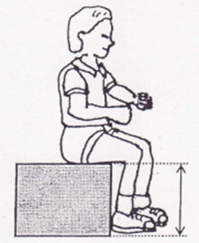 | 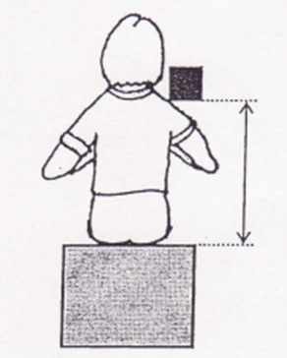 | 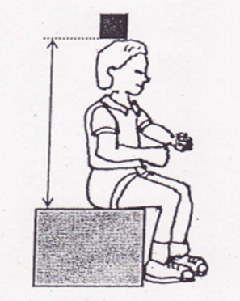
(SL) Shin Length - Measure for the back of the knee to ground. To include shoes normally worn  SL= _____________ | (SH) Shoulder Height – Encourage child to sit upright. Measure from where bottom touches seat to middle of shoulder (not neck or point of shoulder).  SH= _____________ | (HH) Head Height - Measure from where bottom touches seat to top of head  HH=____________

